**Table 1. Diversity estimates for each meadow**. *Needs to include: ENS or α, Shannon (H’), Simpson (S). Im (could go in table 3), beta, gamma, dtc from appendix 5. For the Rsite, I got confused about the superscripts, so I just left them. I think they’re wrong.*

|  |  |  |  |  |  |  |  |  |  |
| --- | --- | --- | --- | --- | --- | --- | --- | --- | --- |
| Site | αplot | H’plot | Splot | Bsite | gammasite | Im | Rsite based on chao et al | Proportion of species with significant I |  |
| DC | 5.68 | 0.41 |  | 13.31 | 17 | 0.47 (0.34 – 0.59) | 15A | 91 |  |
| WI | 5.41 | 0.78 |  | 14.47 | 18 | 0.41 (0.25 – 0.57) | 24BC | 83 |  |
| BE | 4.94 | 0.63 |  | 13.94 | 17 | 0.50 (0.34 – 0.65) | 18ABC | 90 |  |
| EI | 5.56 | 0.70 |  | 9.38 | 13 | 0.44 (0.28 – 0.60) | 15A | 82 |  |
| RP | 8.38 | 1.12 |  | 15.06 | 22 | **0.57 (0.51 – 0.64)** | 24 BC | 93 |  |
| NB | 5.19 | 0.66 |  | 12.69 | 16 | 0.46 (0.28 – 0.64) | 18B | 88 |  |
| CB | 8.81 | 0.63 |  | 10.13 | 14 | 0.53 (0.37 – 0.69) | 21B | 89 |  |
| BI | 6.25 | 0.88 |  | 12.75 | 17 | 0.38 (0.21 – 0.55) | 24BC | 77 |  |
| CC | 4.63 | 0.67 |  | 7.19 | 10 | **0.23 (0.03 – 0.40)** | 15A | 67 |  |
|  |  |  |  |  |  |  |  |  |  |

For Im, 95% CIs should not include 0.5 to indicate

Proportion of species with significant I: based on pschisq in R output

**Table 2: Relative abundance of species in each meadow.** Numbers indicate the rank of abundances relative to other species in that meadow at that time. Species with significant spatial intraspecific aggregation within the meadow, estimated as Morisita’s Index, are indicated in bold. Significance determined by chi-squared tests and P < 0.05. [*I should probably make a printout of the Im results in case we do a bonferroni*] [add a symbol to indicate grazer]

|  |  |  |  |  |  |  |  |  |  |  |  |  |  |  |  |  |  |  |  |  |
| --- | --- | --- | --- | --- | --- | --- | --- | --- | --- | --- | --- | --- | --- | --- | --- | --- | --- | --- | --- | --- |
| **Species** | **T** | **DC** | | | **WI** | | | **BE** | **EI** | **RP** | | | **NB** | | | **CB** | | | **BI** | **CC** |
|  |  | **M** | **J** | **A** | **M** | **J** | **A** | **J** | **J** | **M** | **J** | **A** | **M** | **J** | **A** | **M** | **J** | **A** | **J** | **J** |
| ***Crustacean*** |  |  |  |  |  |  |  |  |  |  |  |  |  |  |  |  |  |  |  |  |
| *Caprella spp.* | 1 | 1 | **1** | 2 | 9 | **5** | 2 | **1** | **4** | 1 | **1** | 2 | 11 | 11 | 6 | 3 | **6** | 4 | 14 | 4 |
| *Aoroides columbiae* | 7 | 2 | **2** | 3 | 5 | 11 | 7 | 10 | **6** | 3 | **8** | 5 |  | 7 | 8 |  | **7** | 13 | **8** |  |
| *Pentidotea resecata* | 8 | 4 | **4** | 5 | 7 | **3** | 5 | **3** | 11 | 6 | **9** | 8 | 1 | **3** | 4 | 2 | **5** | 8 | **6** | 5 |
| *Leptochelia dubia* | 9 |  | 16 | 10 | 10 |  |  | 16 |  | 5 | **5** | 7 | 7 | **5** | 12 | 5 | **4** | 2 | **4** | 7 |
| *Photis brevipes* | 12 | 5 | **3** | 8 | 4 | **7** | 6 | 5 | **7** | 9 | **6** | 9 | 5 | 8 | 3 | 8 | **8** | 5 |  |  |
| *Monocorophium achersicum* | 13 | 6 | **6** | 6 | 14 | 9 | 14 |  |  |  | **18** |  | 9 |  | 9 | 12 | 9 | 6 | 12 | 9 |
| *Amphipod E* | 15 |  | **8** |  | 18 | 15 |  | **2** |  | 10 |  |  |  |  |  | 7 |  |  | **5** | 3 |
| *Pontogeneia rostrata* | 16 | 9 | **5** |  | 2 |  | 8 | 14 | 12 |  | 15 |  | 8 | 15 | 15 | 10 | 13 |  | 10 |  |
| *Harpacticoid copepod* | 17 | 12 | 13 | 16 | 11 | 12 | 18 |  |  |  | **11** | 12 | 3 |  | 5 | 13 |  | 10 |  |  |
| *Eogammarus confervicolus* | 18 | 7 | 12 |  | 12 |  | 16 | **8** | 9 |  |  |  | 13 | 12 |  |  |  |  |  |  |
| *Ampithoe spp.* | 19 | 11 |  | 15 | 13 | 14 | 13 |  |  |  | **16** |  | 14 | 9 | 10 |  |  |  | 15 |  |
| *Balanus spp.* | 21 |  |  | 18 |  |  | 15 |  | 10 |  | **20** | 16 | 16 | 14 | 14 |  |  | 17 |  |  |
| *Cirolana harfordi* | 23 |  | 15 |  | 8 | 13 | 17 | 15 |  |  | **21** |  |  |  |  |  |  |  |  |  |
| *Pugettia richii* | 24 | 13 | 11 | 11 |  |  | 21 |  |  |  |  | 15 |  |  |  |  |  |  |  |  |
| *Pandalidae* | 26 |  |  | 14 |  |  | 20 | 17 |  |  | **17** | 10 |  |  |  |  |  |  |  |  |
| *Pagurus quaylei* | 29 | 14 |  |  | 16 |  | 22 |  |  |  |  |  |  |  |  |  |  |  | 16 |  |
| *Nebalia sp.* | 30 |  |  |  |  |  |  |  |  |  |  |  | 15 |  |  |  |  | 15 |  |  |
|  |  |  |  |  |  |  |  |  |  |  |  |  |  |  |  |  |  |  |  |  |
| ***Gastropod*** |  |  |  |  |  |  |  |  |  |  |  |  |  |  |  |  |  |  |  |  |
| *Phyllaplysia taylori* | 2 | 3 | 10 | 1 | 15 |  | 9 | 9 | **3** | 4 | **2** | 1 |  | 13 |  |  |  |  |  |  |
| *Mytilus trossulus* | 3 |  | 14 | 7 |  | **1** | 1 | **7** | **1** |  | **3** | 4 | 4 | **2** | 1 | 14 | **1** | 1 | **2** | 1 |
| *Lacuna spp.* | 14 | 10 | 9 |  | 6 | **2** | 11 | **4** |  | 8 | **12** | 11 | 10 | 10 | 13 | 15 | 10 | 12 | **7** |  |
| *Margarites helicinus* | 20 |  |  | 12 |  |  | 10 |  |  |  |  |  |  |  |  |  |  |  |  |  |
| *Lottia pelta* | 22 |  |  | 9 | 17 |  | 19 |  |  |  |  |  |  |  |  | 11 |  |  | 13 |  |
| *Haminoea spp.* | 27 |  |  |  |  |  |  |  |  |  | **19** | 13 |  |  |  |  |  | 16 |  |  |
| *Alia carinata* | 28 |  |  |  |  |  |  |  |  |  |  |  |  |  |  |  |  |  | **9** |  |
|  |  |  |  |  |  |  |  |  |  |  |  |  |  |  |  |  |  |  |  |  |
| ***Annelid*** |  |  |  |  |  |  |  |  |  |  |  |  |  |  |  |  |  |  |  |  |
| *Platynereis bicanaliculata* | 4 | 8 | **7** | 4 | 1 | **4** | 4 | **6** | **5** | 2 | **4** | 3 | 6 | **6** | 7 | 4 | 12 | 7 | 11 |  |
| *Janua pagastecheri* | 10 |  |  |  |  | 8 | 3 | 12 |  | 7 | 7 | 6 |  |  |  | 9 |  |  |  |  |
|  |  |  |  |  |  |  |  |  |  |  |  |  |  |  |  |  |  |  |  |  |
| ***Other*** |  |  |  |  |  |  |  |  |  |  |  |  |  |  |  |  |  |  |  |  |
| *Nematode* | 5 |  |  | 13 | 3 | 15 |  |  |  |  | **10** |  | 12 | **1** | 2 |  | **2** | 3 | **1** | 6 |
| *Pycnogonum sp* | 6 |  |  | 17 |  | **6** |  | 13 | **2** |  | 14 | 14 |  |  |  | 1 | 11 | 9 |  | 8 |
| *Halacard mite* | 11 |  |  |  |  | 10 |  | 11 | **8** |  | 13 |  | 2 | **4** |  | 6 | **3** | 11 | **3** | 2 |
| *Nemertea* | 25 |  |  |  |  |  |  |  |  |  |  | 17 | 17 |  | 11 |  |  | 14 |  |  |

**Table 3**: Analysis of metacommunity structure based on three attributes (coherence, species turnover and boundary clumping) of epifaunal taxa in Barkley Sound, British Columbia. Significant results (P < 0.05) are in bold. time C (9 sites). sitesC gives site-level analysis (n = 9 sites) and plotsC gives a plot-level analysis (n = 145).

- embedded absences significantly greater than mean, suggesting significantly negative coherences.

|  |  |  |  |  |  |  |  |  |  |  |  |  |  |  |
| --- | --- | --- | --- | --- | --- | --- | --- | --- | --- | --- | --- | --- | --- | --- |
| **Site** | **Coherence** | |  |  |  | **Turnover** | |  |  |  | **Boundary** | |  | **Structure** |
|  | Abs | z | P | Mean | SD | Rep | z | P | Mean | SD | I | P | df |  |
| **9 sites** |  |  |  |  |  |  |  |  |  |  |  |  |  |  |
| July | 86 | -4.57 | **< 0.01** | 56.17 | 6.53 |  |  |  |  |  |  |  |  | Checkerboard |
|  |  |  |  |  |  |  |  |  |  |  |  |  |  |  |
| **5 sites** |  |  |  |  |  |  |  |  |  |  |  |  |  |  |
| May | 26 | 0.67 | 0.50 | 29.01 | 4.47 |  |  |  |  |  |  |  |  | Random |
| July | 11 | 2.67 | **< 0.01** | 21.24 | 3.83 | 170 | 0.49 | 0.62 | 201.23 | 63.31 | 0 | 0.22 | 29 | Gleasonian |
| Aug | 26 | 1.87 | 0.06 | 35.00 | 4.81 |  |  |  |  |  |  |  |  | Random |
| Times pooled | 22 | 0.63 | 0.53 | 24.53 | 4.01 |  |  |  |  |  |  |  |  |  |
|  |  |  |  |  |  |  |  |  |  |  |  |  |  |  |
| Grazers | |  |  |  |  |  |  |  |  |  |  |  |  |  |
| **9 sites** |  |  |  |  |  |  |  |  |  |  |  |  |  |  |
| July | 16 | 1.04 | 0.30 | 20.30 | 4.13 |  |  |  |  |  |  |  |  | Random |
| July (dfw) | 32 | -2.67 | **< 0.01** | 20.69 | 4.24 |  |  |  |  |  |  |  |  | Checkerboard |
|  |  |  |  |  |  |  |  |  |  |  |  |  |  |  |
| Crustaceans | |  |  |  |  |  |  |  |  |  |  |  |  |  |
| July | 18 | 2.09 | **0.04** | 27.66 | 4.61 | 91 | 1.19 | 0.23 | 156.43 | 54.82 | 2.3 | **< 0.01** | 15 | Clementsian |
| July (dfw) | 45 | -3.74 | **< 0.01** | 27.97 | 4.55 |  |  |  |  |  |  |  |  | Checkerboard |
|  |  |  |  |  |  |  |  |  |  |  |  |  |  |  |
| Gastropods | |  |  |  |  |  |  |  |  |  |  |  |  |  |
| July | 5 | 1.41 | 0.16 | 9.51 | 3.19 |  |  |  |  |  |  |  |  | Random |
|  |  |  |  |  |  |  |  |  |  |  |  |  |  |  |

**Figures**

**Figure 1**: Seagrass is found at the coastal margins of Trevor Channel (approximately 200m deep), one of three channels in Barkley Sound that connect freshwater sources in Alberni Inlet and Numukamis Bay with the open Pacific Ocean. Eelgrass meadows sampled during summer 2012 between Alberni Inlet (red star) and the Pacific Ocean southwest of Dodger Channel (DC). Five meadows were sampled in May, July and August (red dots), while four additional meadows were sampled once in midsummer (yellow dots).   WI = Wizard Islet, BE = Bald Eagle Cove, EI = Ellis Island, RP = Robber’s Passage, NB = Numukamis Bay, CB = Crickett Bay, BI = Boyson Islands, CC = Crow Cove. BMSC = Bamfield Marine Sciences Centre.

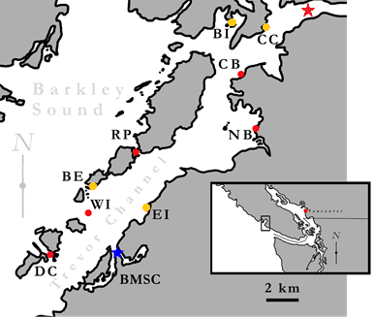

**Figure 2**: Epifaunal diversity from samples of eelgrass meadow (n = 9) of area 0.28m2 in nine meadows in Trevor Channel, British Columbia, in midsummer 2011. Asterisks indicate significant differences (P < 0.01) among sites, based on a one-way anova.

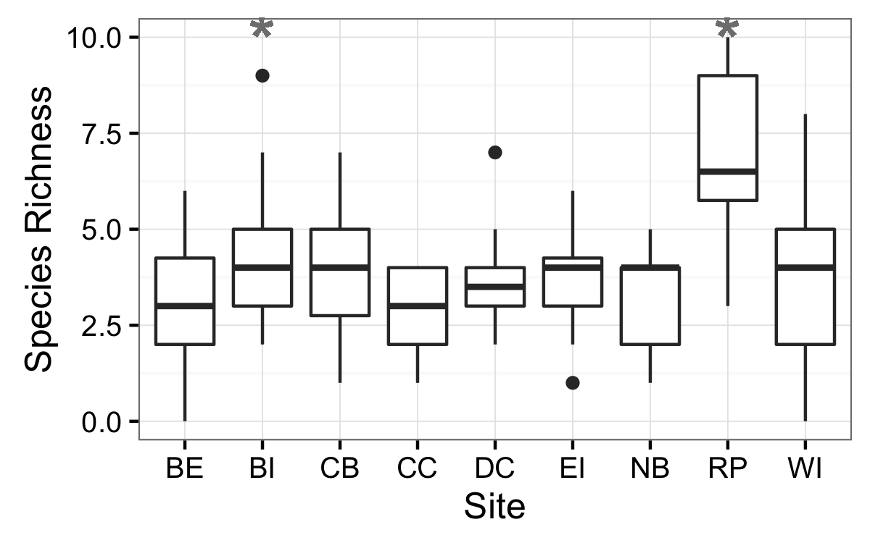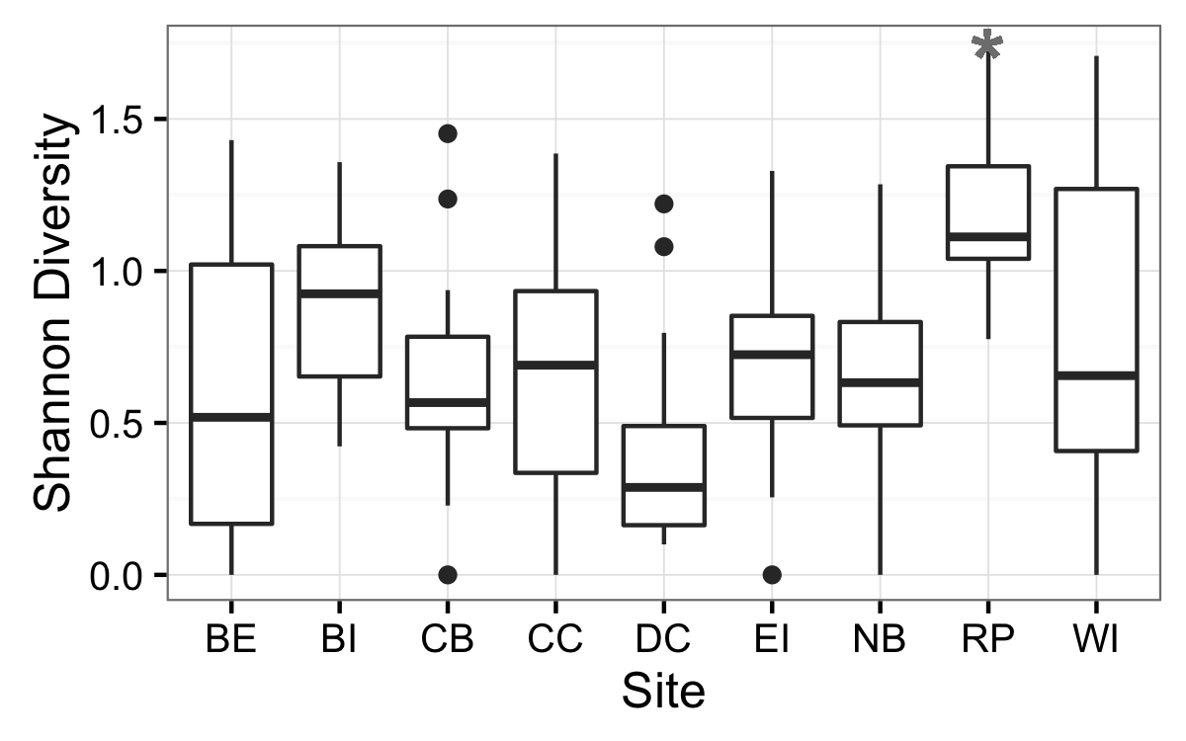

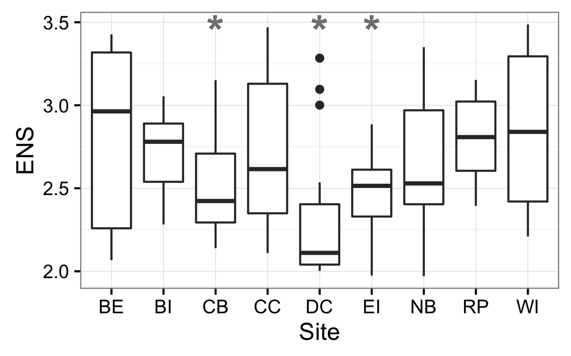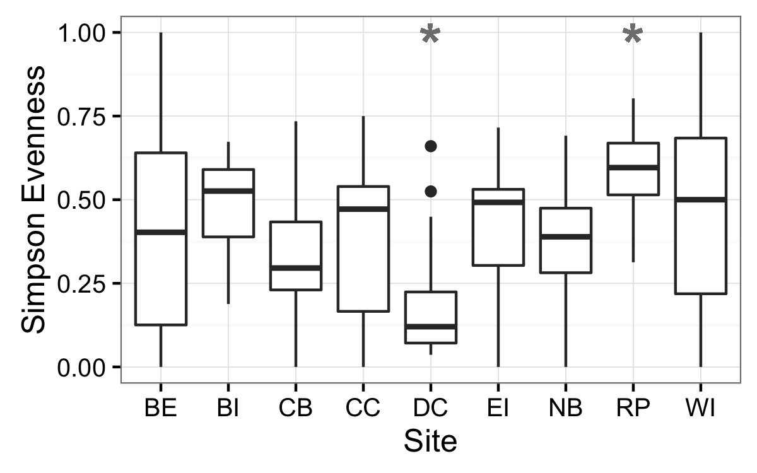

**Figure 3:** Dispersion of multivariate community for each site and sample period using the Bray-Curtis dissimilarity index (Appendix 4). Red filled points represent average median value observed in null model analyses.

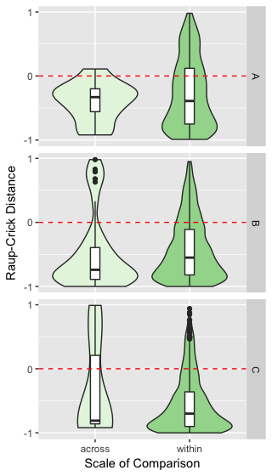

**Figure 4:** Nonmetric Multidimensional Scaling (NMDS) plot visualizing community composition across all sites and times. Polygons represent multivariate communities for each meadow at one time (n = 16 samples per meadow). Polygon area is representative of observed within-meadow beta diversity, such that a larger polygon indicates greater beta diversity among the plots sampled from that meadow. Overlap of polygons indicates similar species composition and relative abundance from plots sampled within different meadows. First two letters of polygon labels are the site codes, given in Table 1 and Figure 1, and the third letter indicates the time period sampled (A = May, C = July, and E = August).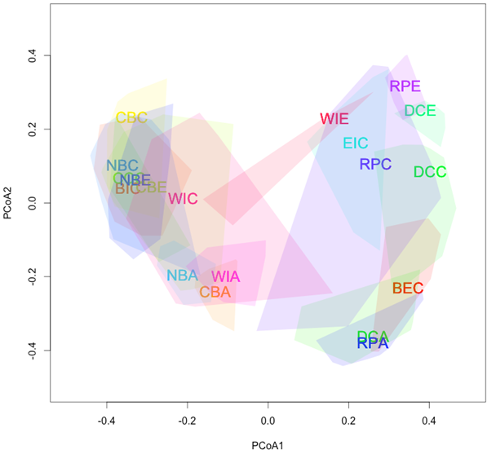

Appendix table S1

**Table A1:** Model selection results for plot-level (n = 9) univariate richness indices across nine eelgrass meadows in July 2011.

|  |  |  |  |  |  |  |
| --- | --- | --- | --- | --- | --- | --- |
| **Model** |  | **Df** | **logLik** | **AICc** | **Delta** | **wt** |
| **alpha** |  |  |  |  |  |  |
| G | Y ~ site | 10 | -271.06 | 565.8 | 0.00 | 1 |
| . | Y ~ area | 3 | -301.43 | 609.0 | 43.27 | 0 |
| D | Y ~ 1 | 2 | -302.59 | 609.3 | 43.50 | 0 |
| A | Y ~ fetch | 3 | -302.28 | 610.7 | 44.97 | 0 |
| B | Y ~ dfw | 3 | -302.51 | 611.2 | 45.43 | 0 |
| C | Y ~ dfw*fetch | 5 | -302.08 | 614.6 | 48.82 | 0 |
| F | Y ~ area*fetch | 5 | -302.14 | 614.7 | 48.95 | 0 |
|  |  |  |  |  |  |  |
| **H’** |  |  |  |  |  |  |
| G | Y ~ site | 10 | -66.12 | 153.9 | 0.00 | 0.998 |
| B | Y ~ dfw | 3 | -81.39 | 168.9 | 15.07 | 0.001 |
| F | Y ~ area*fetch | 5 | -79.57 | 169.6 | 15.69 | 0 |
| C | Y ~ dfw*fetch | 5 | -80.07 | 170.6 | 16.70 | 0 |
| D | Y ~ 1 | 2 | -83.42 | 170.9 | 17.05 | 0 |
| A | Y ~ fetch | 3 | -83.05 | 172.3 | 18.39 | 0 |
| . | Y ~ area | 3 | -83.05 | 172.3 | 18.40 | 0 |
|  |  |  |  |  |  |  |
| **S** |  |  |  |  |  |  |
| G | Y ~ site | 10 | 18.37 | -15.1 | 0.00 | 0.797 |
| F | Y ~ area*fetch | 5 | 11.18 | -11.9 | 3.18 | 0.163 |
| C | Y ~ dfw*fetch | 5 | 9.04 | -7.6 | 7.46 | 0.019 |
| . | Y ~ area | 3 | 6.05 | -5.9 | 9.18 | 0.008 |
| A | Y ~ fetch | 3 | 5.63 | -5.1 | 10.02 | 0.005 |
| B | Y ~ dfw | 3 | 5.48 | -4.8 | 10.32 | 0.005 |
| D | Y ~ 1 | 2 | 3.88 | -3.7 | 11.43 | 0.003 |
|  |  |  |  |  |  |  |
| **ENS** |  |  |  |  |  |  |
| G | Y ~ site | 10 | -52.19 | 126.2 | 0.00 | 0.493 |
| F | Y ~ area*fetch | 5 | -58.67 | 127.8 | 1.57 | 0.225 |
| C | Y ~ dfw*fetch | 5 | -59.21 | 128.9 | 2.66 | 0.130 |
| . | Y ~ area | 3 | -61.59 | 129.4 | 3.13 | 0.103 |
| B | Y ~ dfw | 3 | -63.13 | 132.4 | 6.20 | 0.022 |
| A | Y ~ fetch | 3 | -63.13 | 133.1 | 6.80 | 0.016 |
| D | Y ~ 1 | 2 | -64.88 | 133.9 | 7.62 | 0.011 |